Aggregation grouping data
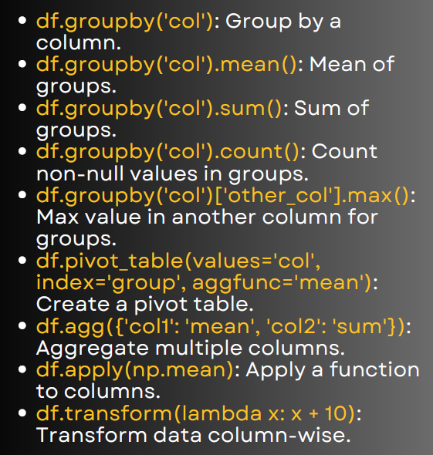

1. Group by a column

import pandas as pd
data = {'Category': ['A','A','B','B','C'],
'Sales': [100, 150, 200, 130, 90],
'Profit': [20, 30, 50, 40, 15]}
df = pd.DataFrame(data)
print(df.groupby('Category'))
Groups the data by Category but does not aggregate yet.

2. Mean of groups
df.groupby('Category').mean()
Gives average Sales and Profit per Category.

3. Sum of groups
df.groupby('Category').sum()
Adds Sales & Profit for each Category.

4. Count values in groups
df.groupby('Category').count()
Counts number of rows in each Category.
5. Max value in another column for groups
df.groupby('Category')['Sales'].max()
Gives highest Sales in each Category.

6. Pivot table
df.pivot_table(values='Sales', index='Category', aggfunc='mean')
Similar to Excel PivotTable – average Sales per Category.

7. Aggregate multiple columns
df.agg({'Sales': 'mean', 'Profit': 'sum'})
Mean of Sales, Sum of Profit.

8. Apply a function
import numpy as np
df.apply(np.mean)
Applies mean to every column.

9. Transform (element-wise)
df['Sales'].transform(lambda x: x + 10)
Adds 10 to every Sales value.

